**Structural Analysis Program**

This Python program is designed to perform a structural analysis on a truss system. It calculates reactions and forces on each element of the truss under specified loads and constraints.

**Usage**

1. **Dependencies**: Make sure you have the following libraries installed:
   * **numpy**
   * **matplotlib**
   * **pandas**
2. **Input Data**: Modify the input data at the beginning of the script to match the geometry and properties of your truss system. This includes node coordinates, constraints, nodal loads, and the adjacency matrix representing connectivity between nodes.
3. **Run the Script**: Execute the script using a Python interpreter.

**Input Data Format**

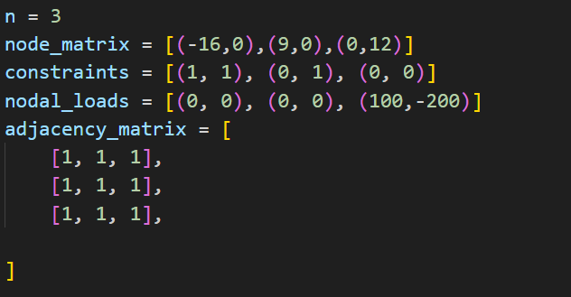

* **node_matrix**: List of tuples containing the (x, y) coordinates of each node.
* **constraints**: List of tuples indicating the constraints at each node. (1, 1) represents a fixed support, (0, 1) represents a roller support in the y-direction, and (1, 0) represents a roller support in the x-direction.
* **nodal_loads**: List of tuples specifying the applied loads at each node.
* **adjacency_matrix**: 2D list representing the connectivity between nodes. A value of 1 at **adjacency_matrix[i][j]** indicates a connection between node **i** and node **j**.

**Output**

The program calculates and prints the reactions at support points and the forces on each element.

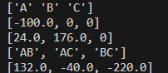

1. **Point Names List**:
   * This list contains the names or labels of points within the truss structure. Each point represents a joint or connection where elements intersect.
2. **X Reaction Force List**:
   * This list stores the calculated reaction forces in the X-direction at the supports of the truss. These forces are generated due to external loads or constraints acting on the structure.
3. **Y Reaction Force List**:
   * Similar to the X Reaction Force List, this list holds the calculated reaction forces in the Y-direction at the supports of the truss. These forces are a result of external loads or constraints applied to the structure.
4. **Element Names List**:
   * This list comprises the names or identifiers of the elements that constitute the truss structure. Each element typically represents a beam or member connecting two points in the truss.
5. **Forces on Each Element List**:
   * Within this list, the forces acting on each element of the truss are recorded. These forces may include tension (positive values) or compression (negative values), depending on how the elements are loaded and how they transfer forces within the structure.
6. **BONUS QUESTION OUTPUT**

These lists serve as essential data structures for analyzing and understanding the behaviour of the truss structure, enabling engineers to assess the internal forces and reactions at various points and elements within the system.

It also generates a visual representation of the truss system with forces labeled on each element.

**Note**

* Ensure that the input data is consistent and represents a valid truss structure.
* The program assumes static equilibrium and does not account for dynamic effects or material properties.

**EXAMPLE 1**

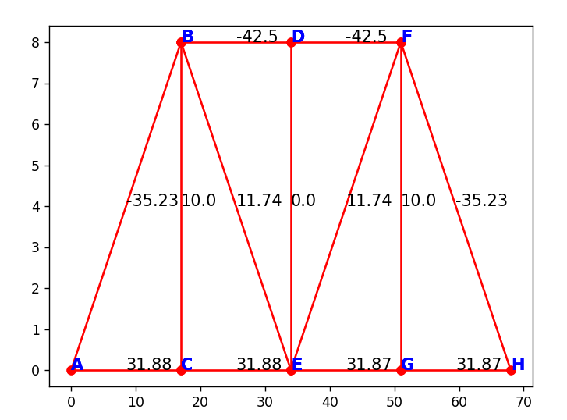

**EXAMPLE 2**

**EXAMPLE 3**

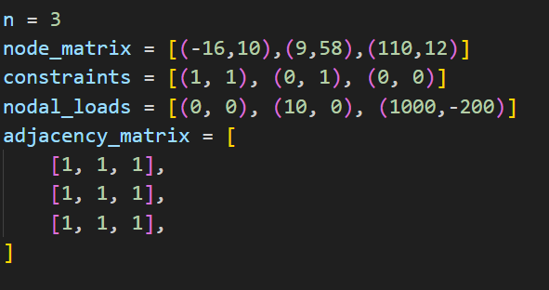

**EXAMPLE 4**

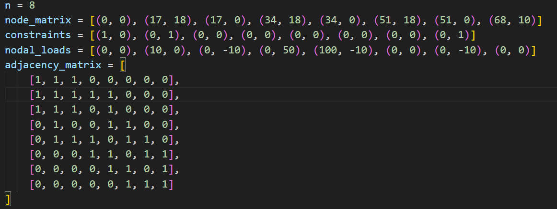

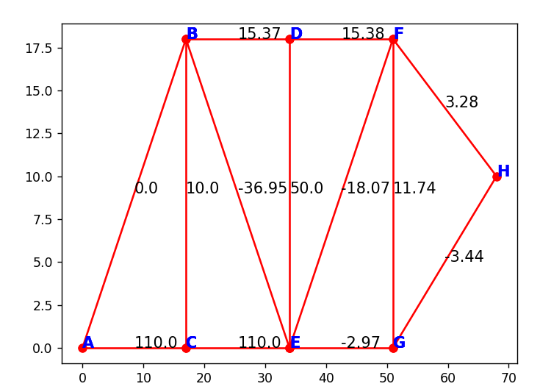

**EXAMPLE 5**

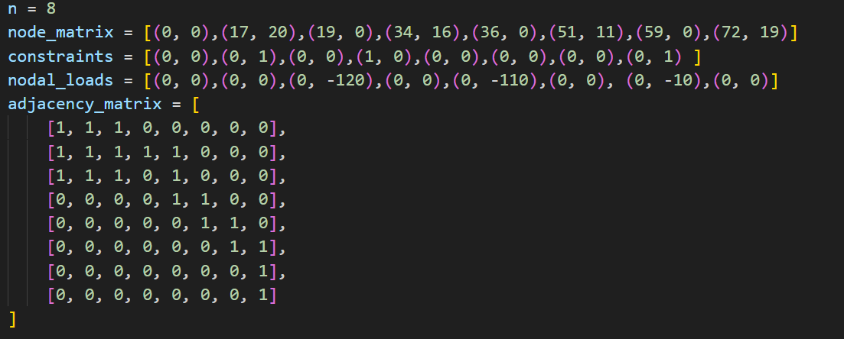

**BONUS QUESTION OUTPUTS:**

Example 1:

Example 2

Example 3

Example 4:

Example 5

Acknowledgment Note:

I would like to acknowledge the use and study of various code snippets from different sources while working on this assignment. Additionally, I utilized the assistance of ChatGPT, to facilitate certain aspects of this task. The collaborative efforts of these resources significantly contributed to the completion of the assignment.